# Assignment – 14 Entering, Deleting, and Changing Field Values

1. Write a command that puts the following values, in their given order, into the salespeople table: city – San Jose, name – Blanco, comm – NULL, cnum – 1100.

INSERT INTO SALESPEOPLE (Snum, Sname, City, Comm) VALUES (1100, 'Blanco', 'San Jose', NULL);

1. Write a command that removes all orders from customer Clemens from the Orders table.

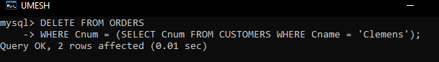

1. Write a command that increases the rating of all customers in Rome by 100.

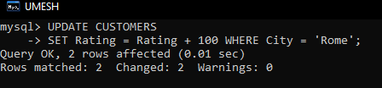

1. Salesperson Serres has left the company. Assign her customers to Motika.

